Submitted To
Dr. Ashraf Uddin
Assistant Professor, CS, AIUB
Project title
Group: G-01, Section: C

AI Usage Declaration
We, the undersigned students, hereby declare that this project and its accompanying report/code have been primarily prepared by our group.
We acknowledge that the use of Artificial Intelligence (AI) tools such as ChatGPT, GitHub Copilot, Grammarly, or similar systems was permitted only to assist in learning, idea generation, code debugging, or language improvement.
We further declare that:
- We have clearly mentioned below the specific purposes for which AI tools were used (if any).
- The core design, implementation, analysis, and conclusions are our own original work.
- We collectively take full academic responsibility for the content of this submission.
AI Usage Details:
☐ No AI tools were used.
☐ AI tools were used for the following purposes (please specify clearly):

 | Name | Student ID | Signature with Date
1.
2.
3.
4.

Table of Contents
About Paragraphs 4
Guideline for Updating TOC, List of Figures and Tables 4
Headings 4
Figures/Tables 4
Guideline for Updating Table of Contents 5
Conclusion 5

List of Table and Figures
Table 1: Write the table caption 5

Fig. 1: Write a proper caption 4

Write a Title of up to 10 Words that Best Describes Your Project
This section should be written as an introductory paragraph without any heading. It must clearly describe the background and context of the project, explaining what the project is about and why it was undertaken. Discuss the main objectives and the problem or need that motivated the work. Briefly outline the approach or methods used to achieve the goals. Finally, include a short summary of the key outcomes, findings, or insights gained from the project. The paragraph should maintain a logical flow and be at least 100 words in length, written in a formal and coherent academic tone.

About Paragraphs
Use the “Normal” style from the Styles menu for all paragraph text. All figures and tables must be mentioned and explained in the text. Each should be referred to by its number (e.g., Fig. 1, Table 2) and accompanied by a brief description or explanation of its content and relevance.

Guideline for Updating TOC, List of Figures and Tables
Ensure all headings, figures, and tables have been properly formatted and captioned before updating. Click anywhere in the TOC.

Headings
Use Word’s built-in heading styles (e.g., Heading 1, Heading 2).

Figures/Tables
Use Insert Caption and select the appropriate label (Figure or Table).
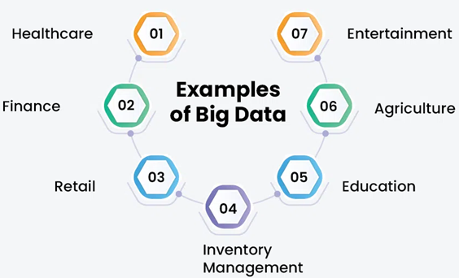
Fig. 1: Write a proper caption

Guideline for Updating Table of Contents
Click anywhere in the TOC. Go to References → Update Table → Update entire table. This ensures all new headings or page number changes are reflected.
Updating List of Figures / List of Tables
Click anywhere in the list. Right-click and choose Update Field → Update entire table. This ensures all new figures/tables or page number changes are included. Repeat updates after making any further edits to headings, figures, or tables to keep the document consistent.
Table 1: Write the table caption
Column 1 | Column 2 | …

Conclusion
Write a single paragraph summarizing the key findings and results of the project. Highlight the significance of these outcomes and how the project objectives were achieved. Optionally, mention limitations and suggest possible future improvements. Keep the paragraph clear, coherent, and at least 100 words in a formal academic tone.

